Contents
Underlying Technology 3
Namespace 3
Control groups 3
Union file systems 3
Container Format 3
Docker objects 3
Docker Architecture 4
Docker Daemon 4
Docker Client 4
Docker Life Cycle 5
Docker command attach vs exec 5
Docker Images 5
Docker Images Layers 5
Docker Networking 6
Bridge 6
Installation 7
Host 7
Macvlan Network 8
None 9
Docker Storage 9
Docker Bind Mount 9
Docker tmpfs Mount 9
Docker Volume Mount 10
Docker DNS 10
External DNS 10
Logging Driver 10
Storage Driver 10
Docker File 10
Entrypoint Vs Cmd 11
CMD shell Vs Exec form 11

Underlying Technology

Namespace
Provide a layer of isolation
Docker Engine user namespace such as:
- pid namespace : process isolation
- net namespace : Managing network interface
- ipc namespace : Managing access to InterProcess Communication resources
- mnt namespace: Managing filesystem mount points
- uts namespace : Isolating kernel and version identifiers

Control groups
Limits an application to a specification set of resources

Union file systems
File systems that operate by creating layers, making it very lightweight and fast

Container Format
Docker Engine combines the namespace control groups and unionFD into a wrapper called container format [libcontanier ~ docker command]

Docker objects
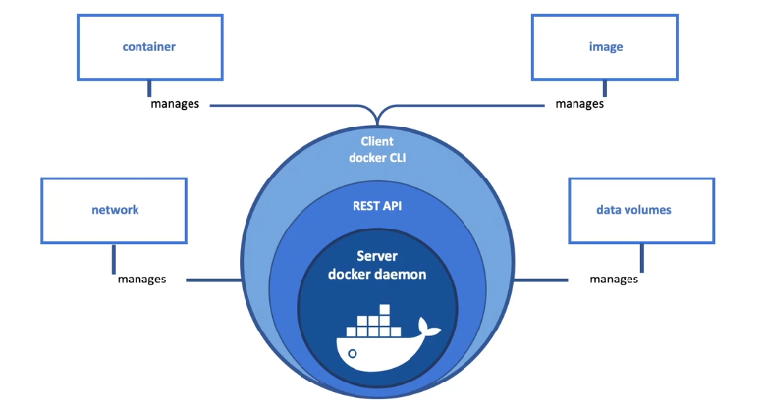

Docker Architecture
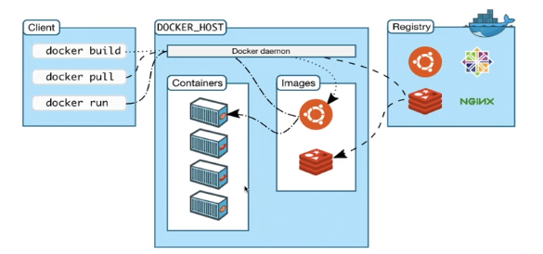

Docker Daemon
- Uses a client-server architure
- Perfoms running, heavy lifting of building and distribution of Docker containers

Docker Client
- Interact with docker application
- Client sends these commands to dockerd
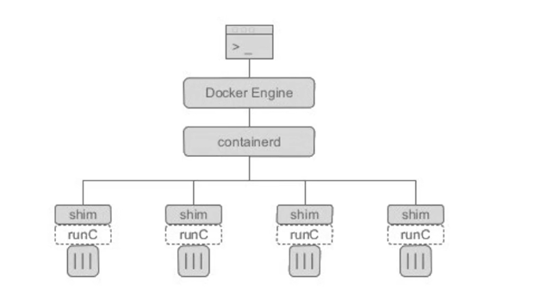
- Dockerd : listen for docker engine api requests
- Conainerd : responsibitly of managing containers life-cycle. It takes the responsibility of executing commands of containers through runc.
- Runc : do all the linux work. Start container and exits
- Containerd-shim : Its is dameonless continers (which doesn’t as any parent process)

Docker Life Cycle

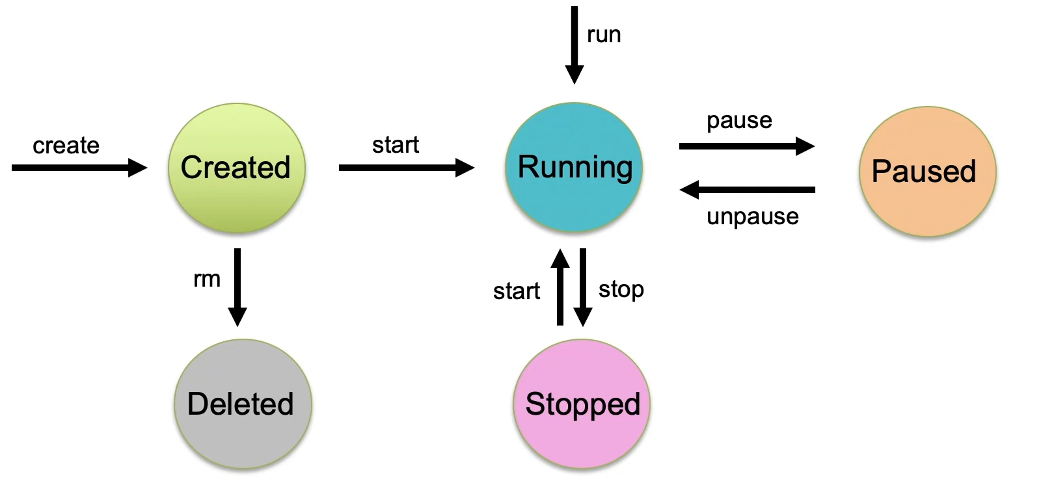

Docker command attach vs exec
Attach | Exec
- Attached to existing primary process | - Create new secondary process

Docker Images
- Read only template
- File used to execute code in a Docker container

Docker Images Layers
- Docker uses Union File System (UFS) to build an image
- Docker image is immutable, and changes made adds new layer on the top
- Container = Image + writable top layer
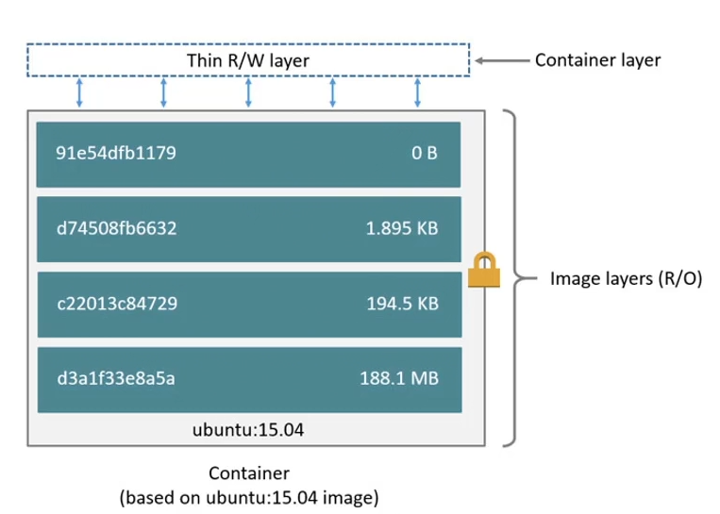

Docker Networking

Bridge
- Default network driver
- Link layer device which fwd traffic b/w network segments
- Software bridge which allows containers connected to the same bridge network to communicate
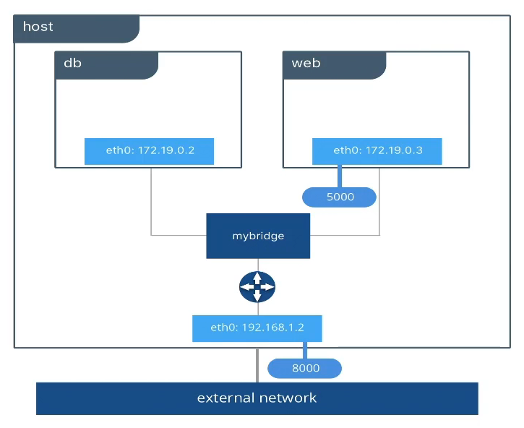

Installation
### Install bridge
sudo apt-get install bridge-utils -y
### Install ping util
apt-get install iputils-ping

Host
- For standalone containers, remove network isolation b/w the container and the Docker host and use the host networking directly
- Container does not get its own IP-address allocated
- Useful to optimize performance
- Does not require network address translation (NAT)
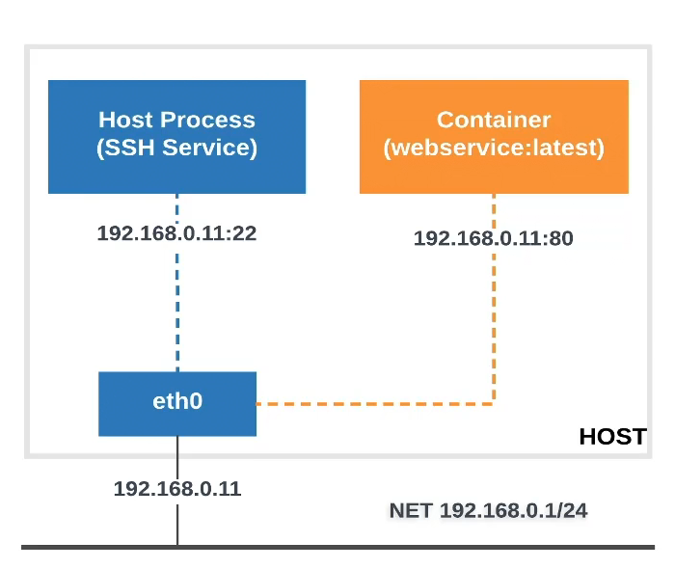

Macvlan Network
- Directly connected to the physical network
- Assigns a MAC address to each container’s virtual network interface
- Usefull to optimize the perfomance
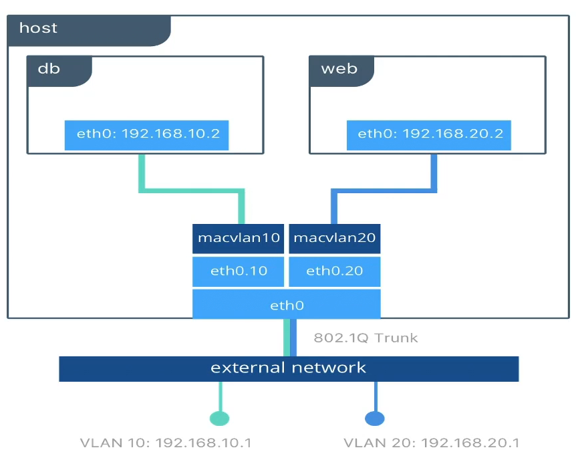

None
- For this container, disable all networking

Docker Storage
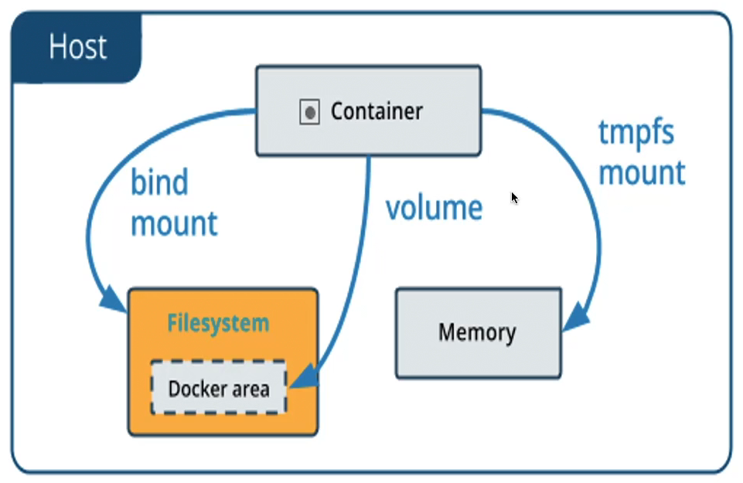

Docker Bind Mount
- File or directory on the host machine is mounted into a container
- It is crated on demand if it does not yet exist with -v option
- If does not exist, it does not create with –mount option
- Can mount in RW or RO access method

Docker tmpfs Mount
- Is not persisted on disk
- It can be used by a container during the lifetime of the container
- Can’t share tmpfs mounts b/w containers
- Only available if your running Docker on linux

Docker Volume Mount
- Volumes are completely managed by Docker
- Which means docker will have complete access to that location it can’t be delete by anyone outside of the container
- Volume can be mounted into multiple containers simultaneously

Docker DNS
- Inbuilt DNS which automatically resolves IP to container names
- In user-defined docker network DNS resolution to container names happens automatically
- When you run new container on the docker host without any DNS related option in command It simply copies host’s /etc/resolv.conf into container
- Docker daemon smartly adds Google’s public nameservers 8.8.8.8 and 8.8.4.4 into file and use it within the container

External DNS
- Define the external DNS IP in docker daemon configuration file /etc/docker/daemon.json
- Restart docker daemon to pick the changes

Logging Driver
- Daemon.json is like configuration file for docker
- Update logging driver for all containers in /etc/docker/daemon.json file
- Use –log-driver to start container with specific driver

Storage Driver
- Storage driver controls how images and containers are stored and managed on your Docker host
- Use –storage-driver to start container with specific driver

Docker File
- Build image automatically by reading the instructions from a Dockerfile
- Text document that contains all the commands a user could call on command line to assemble an image
- The build is run by the docker daemon

Command | Description
FROM | Initializes a new build stage and sets the base image for subsequent instructions
ARG | Passing variables
RUN | Execute any command in a new layer on top of current image
LABEL | Metadata of image
EXPOSE | Informs Docker that the container listens on the specified network port
ENV | Set the environment variable key to the value
ADD | Copies new files, directories or remote files URL’s from source. Advance version of copy which can copy anything
ENTRYPOINT or CMD | Give you a way to identify which executable should be run when a container is started from you image
VOLUME | Set volume
USER | Set the user name (or UID) and optionally user group (or GID)
WORKDIR | Set the working directory for any instructions that follow it in the Dockerfile
COPY | Copy only files for source

Entrypoint Vs Cmd
Entrypoint | Cmd
Where you want the container to behave exclusively as if it were the executable it is wrapping | Where your image have flexibity to run whichever executable they choose when starting the conatiner
 | Only 1 cmd instruction in a Dockerfile
 | If you list more than 1 CMD then only the last CMD will take effect
 | Much easier to override the CMD

Note: Combining ENTRYPOINT and CMD allows you to specify the default executable for your image, let’s also provide default arguments to that executable which may be overridden by the user

CMD shell Vs Exec form
Shell form | Exec form
CMD ping localhost | CMD [“/bin/ping”,”localhost”]
Command in CMD becomes secondary process | Command in CMD becomes primary process

